CODEM BOOTCAMP TASK
WEEK – 3
JAVASCRIPT EXERCISES

SUBMITED BY
Vasundhara P S
IT – III Year

GITHUB LINK : https://github.com/vasujoe2005/CodemBootCamp.git

Task 1: User Profile Object Manipulation
Requirements
- Create an object named userProfile with at least the following properties:
  - name (string)
  - age (number)
  - email (string)
  - isActive (boolean)
- Update at least two properties using dot notation.
- Update at least two properties using bracket notation.
- Add one new property dynamically using bracket notation.
- Display the entire updated object in the console.
- Log each property value individually with clear labels.
PROGRAM :
let userProfile={
name: "Vasundhara P S",
age: 21,
email: "2315028@nec.edu.in",
isActive: true
};
console.log("User Profile Object:");
console.log(userProfile);
userProfile.name ="Vasundhara Joe";
userProfile.age =22;
userProfile["email"]="vasuprabakar1985@gmail.com";
userProfile["isActive"]=false;
userProfile["location"]="Arumuganeri";
console.log("Updated User Profile Object:");
console.log(userProfile);
console.log("Name:", userProfile.name);
console.log("Age:", userProfile.age);
console.log("Email:", userProfile.email);
console.log("Is Active:", userProfile.isActive);
console.log("location:", userProfile.location);

OUTPUT :
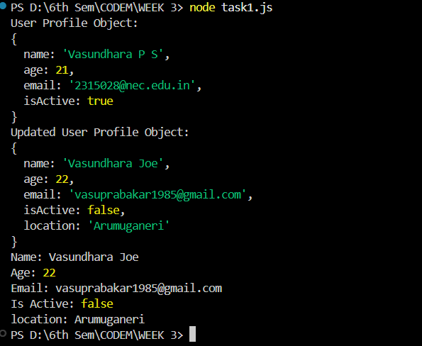

Task 2: Function Modifying an Object
Requirements
- Create an object representing a user or product with at least three properties.
- Write a function that:
  - Accepts the object as a parameter.
  - Modifies two or more properties of the object.
- The function must return a formatted string summarizing the updated object data.
- Call the function and log the returned summary to the console.
- Verify that the original object has been updated.
PROGRAM :
let user = {
name: "Vasundhara P S",
age: 21,
email: "2315028@nec.edu.in",
isActive: false
};
console.log("User Profile Object:");
console.log(user);
function updateUser(userObj) {
userObj.age = userObj.age + 1;
userObj.isActive = true;
userObj.email = "vasuprabakar1985@gmail.com";
return `Updated User Details:
Name: ${userObj.name}
Age: ${userObj.age}
Email: ${userObj.email}
Account Active: ${userObj.isActive}`;
}
let result = updateUser(user);
console.log(result);
console.log("Original Object After Update:", user);

OUTPUT :
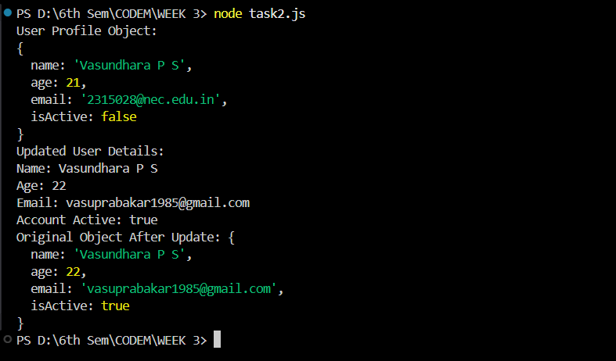

Task 3: Nested Shopping Cart Object
Requirements
- Create a cart object containing:
  - A nested object or array for items.
  - Each item must have name, price, and quantity.
- Access nested properties correctly to calculate the total cost.
- Calculate the total price using object values only (no hardcoded numbers).
- Log the final total price to the console with a clear message.
- Ensure the solution works if item values change.
PROGRAM :
let cart = {
customerName: "Vasu Joe",
items: [
{ name: "Shirt", price: 1200, quantity: 2 },
{ name: "Jeans", price: 2000, quantity: 1 },
{ name: "Shoes", price: 3000, quantity: 1 }
]
};
function calculateTotal(cartObj) {
let total = 0;
cartObj.items.forEach(item => {
total += item.price * item.quantity;
});
return total;
}
let totalPrice = calculateTotal(cart);
console.log(`Total Price of Cart for ${cart.customerName}: ₹${totalPrice}`);
cart.items[0].quantity = 3;
let updatedTotal = calculateTotal(cart);
console.log(`Updated Total Price: ₹${updatedTotal}`);

OUTPUT :
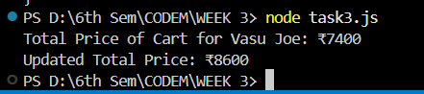

Task 4: Looping Through Student Marks
Requirements
- Create an object where:
  - Keys are student names.
  - Values are marks (numbers).
- Loop through the object using a suitable method.
- For each student:
  - Check if the mark is greater than or equal to the pass mark.
  - Determine pass or fail.
- Log each student’s name, mark, and pass/fail status.
- Do not hardcode student names inside the loop.

PROGRAM :
let studentMarks = {
Harini: 75,
Santhiya: 48,
Joe: 62,
Vasu: 35
};
let passMark = 50;
for (let student in studentMarks) {
let mark = studentMarks[student];
let status = mark >= passMark ? "Pass" : "Fail";
console.log(`Student: ${student}, Mark: ${mark}, Status: ${status}`);
}

OUTPUT :
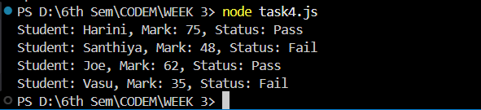

Task 5: Object Methods Using this
Requirements
- Create an object with:
  - At least two properties.
  - At least one method.
- The method must:
  - Use the this keyword to access object properties.
  - Update at least one property of the object.
- Log the updated property values from inside the method.
- Call the method and confirm that the object’s data has changed.
- Log the final object state to the console.
PROGRAM :
let employee = {
name: "Vasu Joe",
salary: 500000,
experience: 2,
promote: function() {
this.salary += 5000;
this.experience += 1;
console.log(`After Promotion:
Name: ${this.name}
Salary: ₹${this.salary}
Experience: ${this.experience} years`);
}
};
console.log("Before Promotion:",employee);
employee.promote();
console.log("Final Object State:", employee);

OUTPUT :
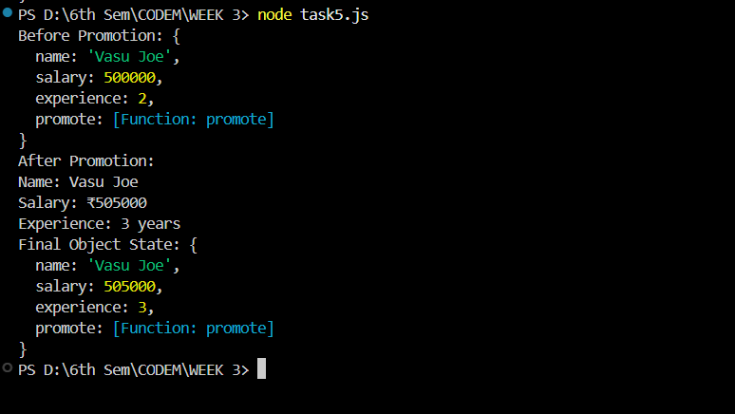

Task 6: Selecting Elements & Updating Content
Requirements
- Create HTML elements that include:
  - At least one element with an id
  - At least two elements sharing the same class
- Select:
  - One element using getElementById()
  - Multiple elements using getElementsByClassName()
  - One element using querySelector()
- Update the textContent of each selected element.
- Change at least two style properties of the selected elements dynamically.
- Ensure all updates happen using JavaScript only.
PROGRAM :
<!DOCTYPE html>
<html>
<head>
<title>Before and After DOM Update</title>
</head>
<body>
<h1 id="mainTitle">Original Title</h1>
<p class="info">Paragraph One</p>
<p class="info">Paragraph Two</p>
<div class="box">This is a box</div>
<button onclick="updateContent()">Update Content</button>
<script>
function updateContent() {
let title = document.getElementById("mainTitle");
let paragraphs = document.getElementsByClassName("info");
let box = document.querySelector(".box");
title.textContent = "Updated Title using getElementById";
paragraphs[0].textContent = "First paragraph updated";
paragraphs[1].textContent = "Second paragraph updated";

box.textContent = "Box updated using querySelector";
title.style.color = "blue";
title.style.fontSize = "30px";
paragraphs[0].style.color = "green";
paragraphs[0].style.backgroundColor = "lightyellow";
paragraphs[1].style.color = "red";
paragraphs[1].style.fontWeight = "bold";
box.style.border = "2px solid black";
box.style.padding = "15px";
box.style.backgroundColor = "lightgray";
}
</script>
</body>
</html>

OUTPUT :

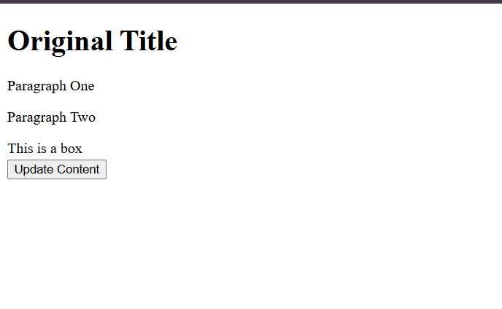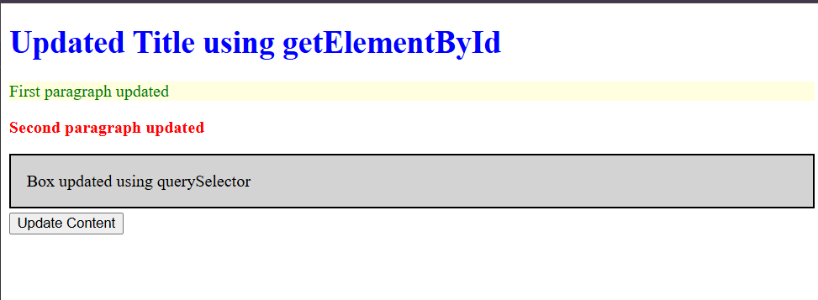

Task 7: Toggle Class on Multiple Elements
Requirements
- Create a button that the user can click.
- Select multiple elements using a class selector.
- Attach a click event listener to the button.
- Loop through the selected elements using a loop.
- Use classList.toggle() to add or remove a CSS class on each element.
- The toggled class must visibly change the element’s appearance.

PROGRAM :
<!DOCTYPE html>
<html>
<head>
<title>Toggle Boxes</title>
<style>
body {
font-family: Arial;
text-align: center;
}
.container {
margin-top: 20px;
}
.box {
width: 150px;
height: 100px;
margin: 10px;
display: inline-block;
background-color: lightblue;
line-height: 100px;
border-radius: 5px;
transition: 0.3s;
}
.active {
background-color: orange;
color: white;
font-weight: bold;
}
</style>
</head>
<body>
<button id="toggleBtn">Toggle Boxes</button>
<div class="container">
<div class="box">Box 1</div>
<div class="box">Box 2</div>
<div class="box">Box 3</div>
</div>
<script>
let button = document.getElementById("toggleBtn");
let boxes = document.getElementsByClassName("box");
button.addEventListener("click", function() {
for (let i = 0; i < boxes.length; i++) {
boxes[i].classList.toggle("active");
}
});
</script>
</body>
</html>

OUTPUT :

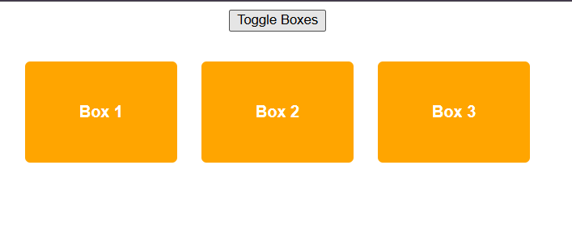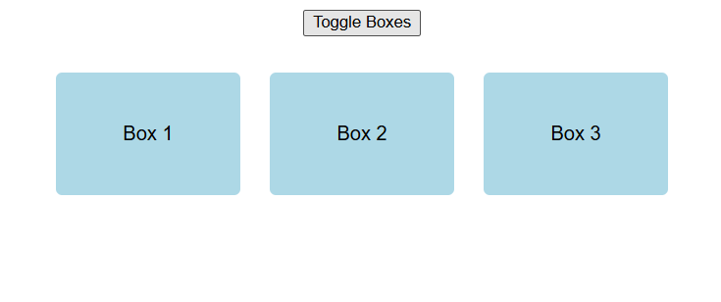
Task 8: Dynamically Create a List from Objects
Requirements
- Create an array containing objects (each object should have at least two properties).
- Select a container element from the DOM.
- Dynamically create a list element (ul or ol) using createElement().
- Loop through the array and:
  - Create a list item for each object.
  - Insert object data into the list item using textContent.
- Append each list item to the list using appendChild().
- Append the final list to the DOM.
PROGRAM :
<!DOCTYPE html>
<html>
<head>
<title>Dynamic List from Objects</title>
</head>
<body>
<div id="listContainer"></div>
<script>
let products = [
{ name: "Strawberry", price: 200 },
{ name: "Blueberry", price: 180 },
{ name: "Raspberry", price: 215 }
];
let container = document.getElementById("listContainer");
let ul = document.createElement("ul");

products.forEach(function(product) {
let li = document.createElement("li");
li.textContent = `Product: ${product.name}, Price: ₹${product.price}`;
ul.appendChild(li);
});
container.appendChild(ul);
</script>
</body>
</html>

OUTPUT :
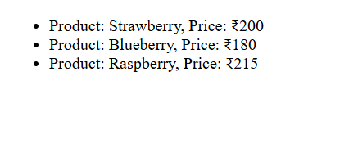

Task 9: DOM Traversal
Requirements
- Select a specific element from the DOM.
- Access and modify:
  - Its parent element
  - At least one child element
  - One sibling element
- Update either the textContent or styles of the traversed elements.
- Use DOM traversal properties only (no re-selecting elements).
- Ensure the changes are visible in the browser.
PROGRAM :
<!DOCTYPE html>
<html>
<head>
<title>DOM Traversal Example</title>
<style>
.container {
padding: 20px;
border: 2px solid black;
}
.box {
padding: 10px;
margin: 5px;
background-color: lightgray;
}
</style>
</head>

<body>
<div class="container">
<div class="box">Box 1</div>
<div class="box" id="target">Box 2 (Target)</div>
<div class="box">Box 3</div>
</div>
<button onclick="traverseDOM()">Modify Elements</button>
<script>
function traverseDOM() {
let target = document.getElementById("target");
let parent = target.parentElement;
parent.style.backgroundColor = "lightblue";
let firstChild = parent.firstElementChild;
firstChild.textContent = "Box 1 Updated";
firstChild.style.color = "red";
let sibling = target.nextElementSibling;
sibling.style.backgroundColor = "yellow";
sibling.textContent = "Box 3 Updated";
target.style.fontWeight = "bold";
target.textContent = "Target Modified";
}
</script>
</body>
</html>

OUTPUT :
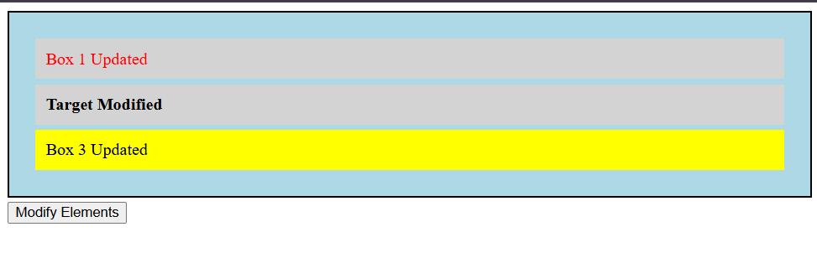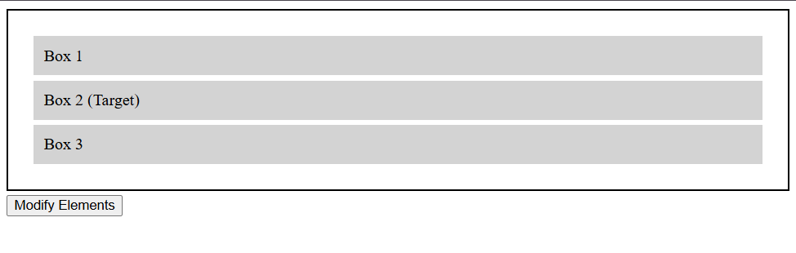

Task 10: Attribute Manipulation Based on User Interaction
Requirements
- Create at least one interactive element (button or checkbox).
- Select a target element whose attribute will be modified.
- On user interaction:
  - Check if a specific attribute exists using hasAttribute().
  - Add the attribute using setAttribute() if it does not exist.
  - Remove the attribute using removeAttribute() if it exists.
- The attribute change must affect the element’s behavior or appearance.
- Log the attribute state to the console after each interaction.
PROGRAM :
<!DOCTYPE html>
<html>
<head>
<title>Attribute Manipulation</title>
</head>
<body>
<h2> Attribute Manipulation Based on User Interaction </h2>
<button id="toggleBtn">Toggle Disable</button>
<br><br>
<input type="text" id="textInput" placeholder="Type something here">
<script>
const toggleBtn = document.getElementById("toggleBtn");
const textInput = document.getElementById("textInput");
toggleBtn.addEventListener("click", function () {
if (textInput.hasAttribute("disabled")) {
textInput.removeAttribute("disabled");
console.log("Attribute removed: disabled = false");
}
else {
textInput.setAttribute("disabled", "true");
console.log("Attribute added: disabled = true");
}
});
</script>
</body>
</html>

OUTPUT :
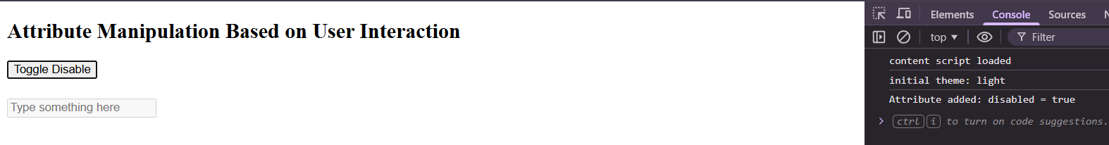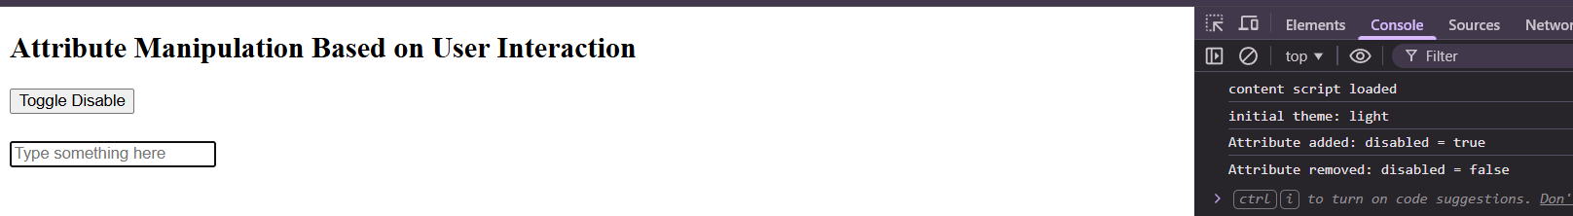

Task 11: Using the Event Object with Multiple Buttons
Requirements
- Create at least three buttons on the page.
- Select all buttons using a single selector.
- Attach the same event listener to each button.
- Use the event object to:
  - Identify which button was clicked.
  - Identify the event type.
- Display the clicked button’s text and event type inside the DOM.
- Ensure the output updates every time a button is clicked.
PROGRAM :
<!DOCTYPE html>
<html>
<head>
<title>Event Object with Multiple Buttons</title>
</head>
<body>

<h2>Click Any Button</h2>
<button class="actionBtn">Save</button>
<button class="actionBtn">Edit</button>
<button class="actionBtn">Delete</button>
<br><br>
<div id="output"></div>
<script>
const buttons = document.querySelectorAll(".actionBtn");
const output = document.getElementById("output");
buttons.forEach(function (button) {
button.addEventListener("click", handleClick);
});
function handleClick(event) {
const buttonText = event.target.textContent;
const eventType = event.type;
output.textContent = "You clicked: " + buttonText +" and Event Type: " + eventType;
}
</script>
</body>
</html>

OUTPUT :
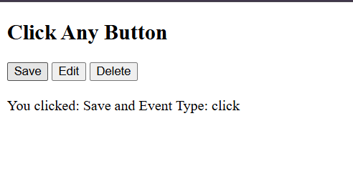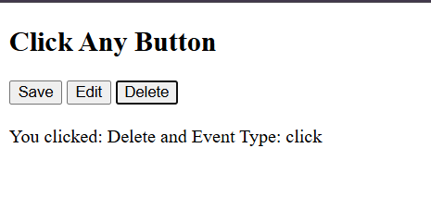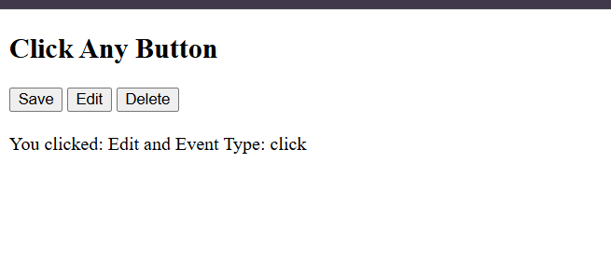
Task 12: Form Validation with Prevent Default
Requirements
- Create a form with at least two input fields and a submit button.
- Attach a submit event listener to the form.
- Prevent the default form submission behavior.
- Validate that all required fields are filled.
- Display an error message inside the DOM for each empty field.
- Allow form submission logic to continue only when all fields are valid.
PROGRAM :
<!DOCTYPE html>
<html>
<head>
<title>Form Validation</title>
<style>
.error {
color: red;
font-size: 14px;
}
</style>
</head>
<body>
<h2>Registration Form</h2>
<form id="myForm">
<div>
<label>Full Name:</label>
<input type="text" id="fullName">
<div id="nameError" class="error"></div>
</div>
<br>
<div>
<label>Email:</label>
<input type="text" id="email">
<div id="emailError" class="error"></div>
</div>
<br>
<button type="submit">Register</button>
</form>
<div id="successMessage"></div>

<script>
const form = document.getElementById("myForm");
const fullName = document.getElementById("fullName");
const email = document.getElementById("email");
const nameError = document.getElementById("nameError");
const emailError = document.getElementById("emailError");
const successMessage = document.getElementById("successMessage");
form.addEventListener("submit", function (event) {
event.preventDefault();
let isValid = true;
nameError.textContent = "";
emailError.textContent = "";
successMessage.textContent = "";
if (fullName.value.trim() === "") {
nameError.textContent = "Full Name is required.";
isValid = false;
}
if (email.value.trim() === "") {
emailError.textContent = "Email is required.";
isValid = false;
}
if (isValid) {
successMessage.textContent = "Registration successful!";
}
});
</script>
</body>
</html>

OUTPUT :
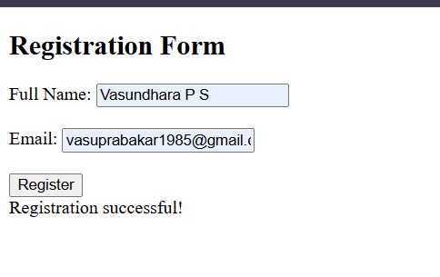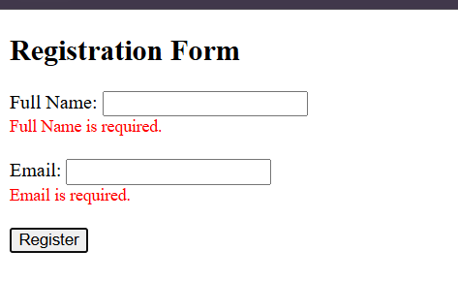
Task 13: Real-Time Input Validation
Requirements
- Create a form with multiple input fields.
- Validate input values while the user types using an appropriate event.
- Highlight invalid inputs by:
  - Adding a CSS class when invalid.
  - Removing the class when valid.
- Display real-time validation messages next to each input.
- Ensure validation feedback updates immediately as input changes.

PROGRAM :
<!DOCTYPE html>
<html>
<head>
<title>Real-Time Input Validation</title>
<style>
.invalid {
border: 2px solid red;
}
.error-message {
color: red;
font-size: 14px;
margin-left: 10px;
}
</style>
</head>
<body>
<h2>Registration Form</h2>
<form>
<div>
<label>Name:</label>
<input type="text" id="name">
<span id="nameError" class="error-message"></span>
</div>
<br>
<div>
<label>Email:</label>
<input type="text" id="email">
<span id="emailError" class="error-message"></span>
</div>
<br>
<div>
<label>Password:</label>
<input type="password" id="password">
<span id="passwordError" class="error-message"></span>
</div>
</form>
<script>
const nameInput = document.getElementById("name");
const emailInput = document.getElementById("email");
const passwordInput = document.getElementById("password");
const nameError = document.getElementById("nameError");
const emailError = document.getElementById("emailError");
const passwordError = document.getElementById("passwordError");
nameInput.addEventListener("input", function () {
if (nameInput.value.trim().length < 3) {
nameInput.classList.add("invalid");
nameError.textContent = "Name must be at least 3 characters.";
} else {
nameInput.classList.remove("invalid");
nameError.textContent = "";
}
});

emailInput.addEventListener("input", function () {
const emailPattern = /^[^ ]+@[^ ]+\.[a-z]{2,3}$/;

if (!emailPattern.test(emailInput.value)) {
emailInput.classList.add("invalid");
emailError.textContent = "Enter a valid email address.";
} else {
emailInput.classList.remove("invalid");
emailError.textContent = "";
}
});
passwordInput.addEventListener("input", function () {
if (passwordInput.value.length < 6) {
passwordInput.classList.add("invalid");
passwordError.textContent = "Password must be at least 6 characters.";
} else {
passwordInput.classList.remove("invalid");
passwordError.textContent = "";
}
});
</script>
</body>
</html>

OUTPUT :
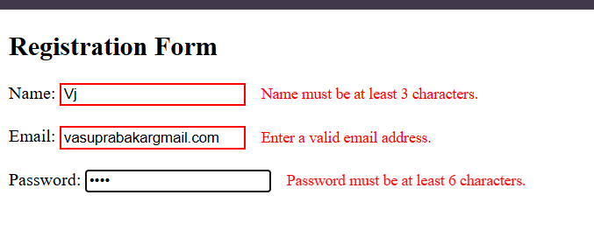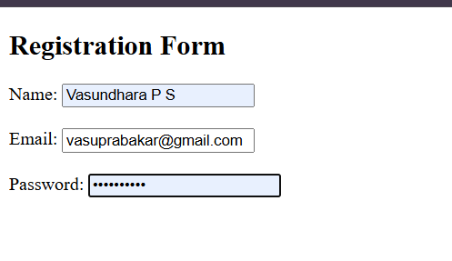

Task 14: Keyboard Events Interaction
Requirements
- Select an element where content will be displayed dynamically.
- Listen for both keydown and keyup events.
- Detect specific keys pressed by the user.
- Update the content or style of the selected element based on the key pressed.
- Use the event object to identify the key.
- Ensure the page responds instantly to keyboard input.
PROGRAM :
<!DOCTYPE html>
<html>
<head>
<title>Keyboard Events Interaction</title>
</head>
<body>
<h2>Press Any Key</h2>
<div id="display">Waiting for key press...</div>
<script>
const display = document.getElementById("display");
document.addEventListener("keydown", function (event) {
const keyPressed = event.key;
display.textContent = "Key Down: " + keyPressed;
if (keyPressed === "Enter") {
display.textContent = "You pressed ENTER";
}
else if (keyPressed === "Escape") {
display.textContent = "You pressed ESCAPE";
}
else if (keyPressed === "a" || keyPressed === "A") {
display.textContent = "You pressed A";
}
});
document.addEventListener("keyup", function (event) {
const keyReleased = event.key;
display.textContent = "Key Up: " + keyReleased;
});
</script>
</body>
</html>

OUTPUT :
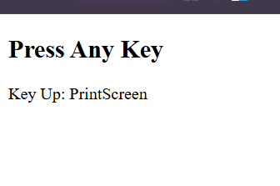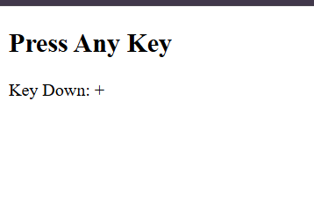

Task 15: Interactive To-Do List with Validation
Requirements
- Create an object named todoData to store tasks added by the user.
- Dynamically create an input field, an add button, and a task list using JavaScript.
- Allow users to mark tasks as completed and remove tasks using click events.
- Update both the DOM and the todoData object when tasks are added or removed.
- Reuse DOM references and ensure all interactions work on a single page without reloads.

PROGRAM :
<!DOCTYPE html>
<html>
<head>
<title>Interactive To-Do List</title>
<style>
body {
font-family: Arial, sans-serif;
padding: 30px;
}
#todoContainer {
width: 400px;
}
input {
width: 70%;
padding: 8px;
}
button {
padding: 8px 12px;
margin-left: 5px;
cursor: pointer;
}
ul {
list-style: none;
padding: 0;
margin-top: 20px;
}
li {
padding: 8px;
margin-bottom: 5px;
background: #f2f2f2;
display: flex;
justify-content: space-between;
align-items: center;
}
.completed {
text-decoration: line-through;
color: gray;
}

.removeBtn {
background: red;
color: white;
border: none;
padding: 5px 8px;
cursor: pointer;
}
</style>
</head>
<body>
<script>
let todoData = {
tasks: []
};
const container = document.createElement("div");
container.id = "todoContainer";
const input = document.createElement("input");
input.type = "text";
input.placeholder = "Enter a task";
const addButton = document.createElement("button");
addButton.textContent = "Add";
const taskList = document.createElement("ul");
container.appendChild(input);
container.appendChild(addButton);
container.appendChild(taskList);
document.body.appendChild(container);
function addTask() {
const taskText = input.value.trim();
if (taskText === "") {
alert("Task cannot be empty");
return;
}
const taskObj = {
id: Date.now(),
text: taskText,
completed: false
};
todoData.tasks.push(taskObj);
renderTask(taskObj);
input.value = "";
}
function renderTask(taskObj) {
const li = document.createElement("li");
li.dataset.id = taskObj.id;
const span = document.createElement("span");
span.textContent = taskObj.text;
span.addEventListener("click", function () {
taskObj.completed = !taskObj.completed;
span.classList.toggle("completed");
});
const removeBtn = document.createElement("button");
removeBtn.textContent = "X";
removeBtn.className = "removeBtn";

removeBtn.addEventListener("click", function () {
todoData.tasks = todoData.tasks.filter(
function (t) {
return t.id !== taskObj.id;
}
);
taskList.removeChild(li);
});
li.appendChild(span);
li.appendChild(removeBtn);
taskList.appendChild(li);
}
addButton.addEventListener("click", addTask);
input.addEventListener("keypress", function (e) {
if (e.key === "Enter") {
addTask();
}
});
</script>
</body>
</html>

OUTPUT :
